# Introduction

The assignment is targeted to test the skills of the candidate in HTML.

# Objective

This assignment will help master the concepts of HTML.

# Pre-requisites

Not applicable.

# Associated Data Files

Not applicable.

# Problem Statement

1. Design a HTML page having body, head & title.
2. Add a paragraph and an image to the page.
3. Now, delete the image from the file system and make sure an alternate text is displayed in the place of the image.
4. Use the INS and DEL tags to represent inserted and deleted text respectively.
5. Display a text with superscript and subscript using the appropriate tags.
6. Display the following list using Ordered and unordered lists accordingly

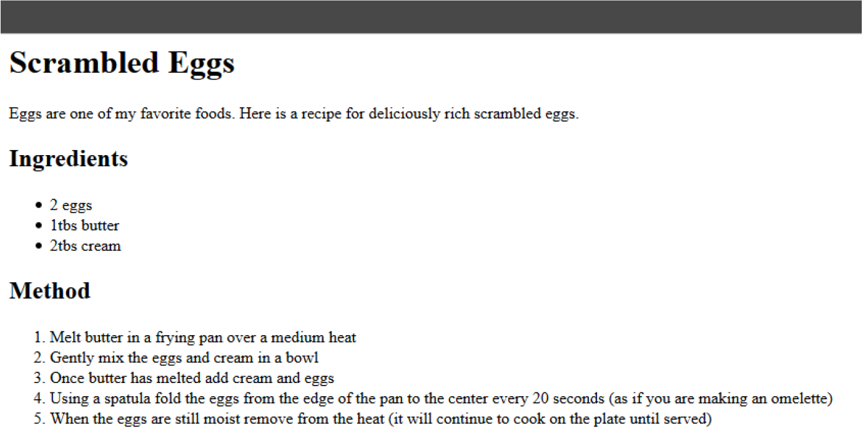

1. Create the following form using HTML form tags.

